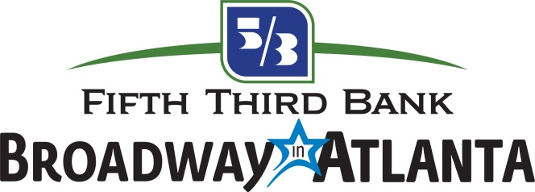
For more information:
Katie Phelan
BRAVE Public Relations
404.233.3993
kphelan@emailbrave.com

Fifth Third Bank Broadway in Atlanta Unveils Five-Show Packages
for 40th Anniversary Season at the Fox Theatre

ATLANTA (Sept. 8, 2021) – With this season currently underway, Fifth Third Bank Broadway in Atlanta is proud to announce five-show packages to provide local theatre fans exciting performances all season long. On sale now, these limited packages will include a sampling of the highly anticipated shows in the 40th anniversary season, including TOOTSIE and MEAN GIRLS at the Fox Theatre.

The five-show package includes:
TOOTSIE (Jan. 25-30, 2022)
AIN’T TOO PROUD: The Life and Times of the Temptations (Mar. 8-13, 2022)
JESUS CHRIST SUPER STAR (Apr. 19-24, 2022)
Disney’s FROZEN (June 2-12, 2022)
MEAN GIRLS (July 19-24, 2022)
Fifth Third Bank Broadway in Atlanta’s 2021/2022 five-show packages are on sale now with prices starting at $224. Subscriber prices will vary depending on the show time, day of the week and seating location. New subscriptions may be ordered online at BroadwayInAtlanta.com and via phone by calling 800-278-4447 Monday through Friday, 9 a.m. to 5 p.m. Subscriber benefits include access to the best seats available, priority access to additional tickets, and ticket exchange privileges.

Performances are Tuesday through Thursday at 7:30 p.m., Friday at 8 p.m., Saturday at 2 p.m. and 8 p.m., and Sunday at 1 p.m. and 6:30 p.m. (All times are subject to change.) An American Sign Language-interpreted performance for the deaf and hearing-impaired is available for a pre-determined Sunday matinee of each engagement.

Fifth Third Bank Broadway in Atlanta is working alongside the Fox Theatre to implement all necessary health and wellness precautions for the 2021/2022 shows. Local and state guidelines will be followed at each show to ensure the safety of each audience member. For more information on safety measures, visit foxtheatre.org.

Subscription packages for the 2021/2022 season do not include tickets to FIDDLER ON THE ROOF, DR. SEUSS’ HOW THE GRINCH STOLE CHRISTMAS! THE MUSICAL, BEAUTIFUL – THE CAROLE KING MUSICAL AND BLUE MAN GROUP but can be included for an additional purchase. These shows are subject to availability and seats are sold on a first come first serve basis. For more information and subscription terms, visit BroadwayAcrossAmerica.com/SubscriberTerms or BroadwayAcrossAmerica.com.

###
Broadway Across America (BAA) is part of the John Gore Organization family of companies, which includes Broadway.com, The Broadway Channel, BroadwayBox.com and Group Sales Box Office. Led by 14-time Tony-winning theater producer John Gore (Owner & CEO), BAA is the foremost presenter of first-class touring productions in North America, operating in 47 markets with over 400,000 subscribers. Presentations include Disney’s The Lion King, Wicked, The Book of Mormon, The Phantom of the Opera and Hamilton. Current and past productions include Ain’t Too Proud, Beautiful, Cats, Chicago, Dear Evan Hansen, Mean Girls, Moulin Rouge! and To Kill A Mockingbird.
The John Gore Organization is the leading developer, producer, distributor and marketer of Broadway theatre worldwide. Under the leadership of 14-time Tony-winning theater producer and owner John Gore, its family of companies includes Broadway Across America, Broadway.com, The Broadway Channel, BroadwayBox.com and Group Sales Box Office. The company presents shows in 47 cities across North America as well as on Broadway, Off-Broadway, London’s West End, Japan, and China. It has won Tony Awards in every producing category as well as numerous other Drama League, Drama Desk and Olivier awards.

